**Exercise 6: Cursors**

**Scenario 1:** Generate monthly statements for all customers.

* **Question:** Write a PL/SQL block using an explicit cursor **GenerateMonthlyStatements** that retrieves all transactions for the current month and prints a statement for each customer.  
  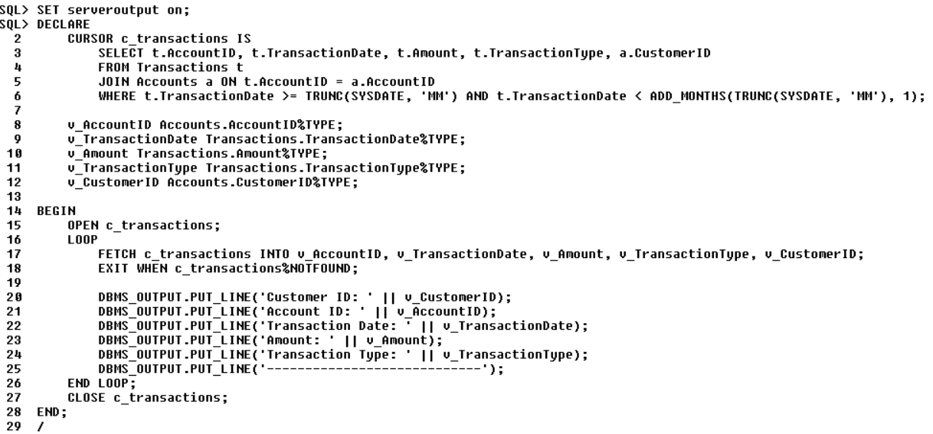  
  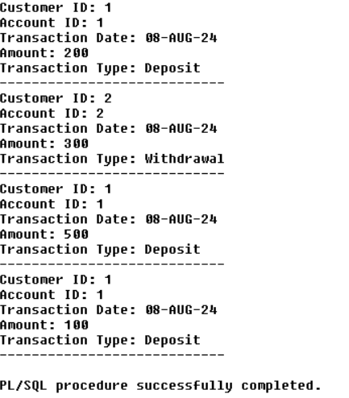

**Scenario 2:** Apply annual fee to all accounts.

* **Question:** Write a PL/SQL block using an explicit cursor **ApplyAnnualFee** that deducts an annual maintenance fee from the balance of all accounts.  
  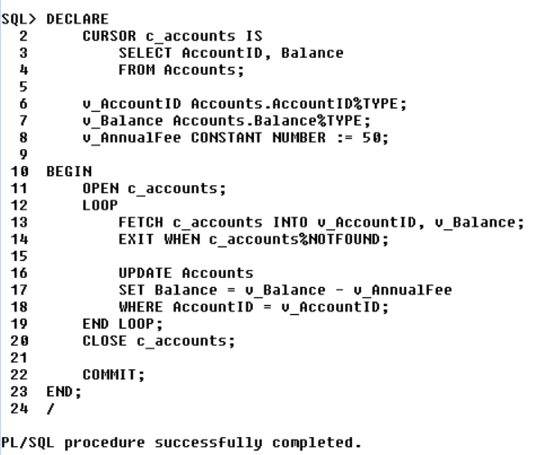  
  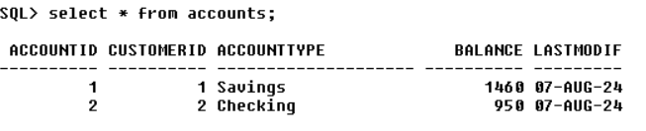

**Scenario 3:** Update the interest rate for all loans based on a new policy.

* **Question:** Write a PL/SQL block using an explicit cursor **UpdateLoanInterestRates** that fetches all loans and updates their interest rates based on the new policy.  
  